[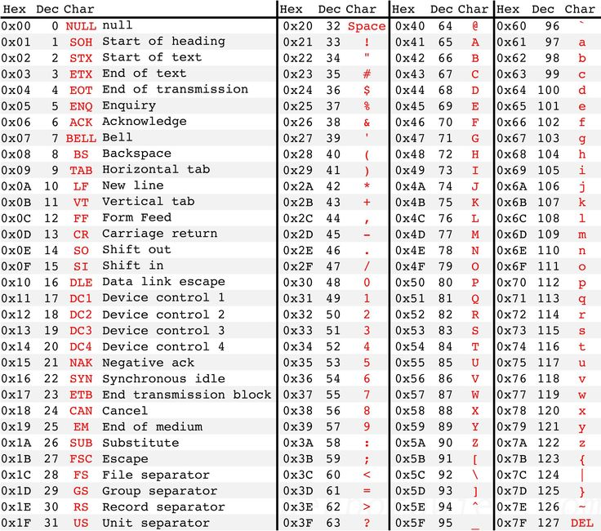](https://www.google.com/url?sa=i&rct=j&q=&esrc=s&source=images&cd=&cad=rja&uact=8&ved=0ahUKEwiLvpOp8NXLAhWDXB4KHdPRB_sQjRwIBw&url=https://www.pinterest.com/pin/569494315354562943/&psig=AFQjCNE4beRhfI21SlGWX04xeiJUYiloLg&ust=1458790510074592)

s = "fur"

for i in ["deer", "horse", "dog"]:

s=i+s

print(s)

p = 1

k = 1

while k <= 5:

p = p*k

print(p)

k = k+2

print("done") **1e3e15edone**

if x == 0:

print('Zero')

if (x%3)==0:

print('Mult3')

if not((x==0) or ((x%3)==0)):

print('not mult3')

def Simple(x):

if x ==1:

return("one")

elif x==2:

return("two")

elif x==3:

return("three")

else:

return(None)

assertEqual(Simple(1),1)

assertEqual(Simple(5),None)

def main():

inp = input("Enter an integer 1 through 4:")

while int(inp) != 4:

if int(inp) == 1:

print(Simple(1))

inp = input('new choice:')

elif int(inp) == 2:

print(Simple(2))

inp = input('new choice:')

elif int(inp) == 3:

print(Simple(3))

inp = input('new choice:')

else:

inp = input("invalid choice try again:")

if int(inp) == 4:

print('Goodbye')

main()

*other: randrange: rand range value*

*format(#,.2f)(#,’%’)(#,’e’)(#,’d’)*

def h(x):

return(x+5)

print(h(h(h(3)))) **18**

def bigger(x,y):

if(x>y):

print(x)

else:

print(y)

return

x = bigger(11,12)

print(x) **12eNone**

d = True and True or False

t = True or False and True

q = False and False or True

if d == True:

print('True') **True**

if t == True:

print('True') **True**

if q == True:

print('True') **True**

number = randint(1,50)

print(number)

#The while loop is a pretest type of loop

#Posttest loops always test at least once

#Infinite loop loops until interrupted externally

x = [3,6,9,12,15,18]

for i in [1,5,3]:

print(x[i]) **6e18e12**

for x in [2,6,8,5,5]:

for y in range(1,5):

print(x,y)

executes 20 times

x = 60

if x<100:

grade = 'a'

elif x<90:

grade = 'b'

elif x<80:

grade = 'c'

else:

grade = 'd'

print(grade)

**just a**

*Seed: random value generate point*

*Semantic/syntax errors: logic vs type*

if "Mark" <= "Mary":

print('True')**True**

if (not((5<3) or (8>5))) == False:

print("False") **False**

def summult(x,y):

if (x>y):

result = x*y

else:

result = x+y

return(result)

x = summult(5,10)

print(x) **15**

a=9

b=a

b=b-3

a=b+3

print(a,b) **9 6**

m=11

n=77

n=m

m=n

print(n,m) **11 11**

Sum=0

for b in [2,4,6,8]:

Sum = Sum + b + 1

print(Sum) **3e8e15e24**

print(sum(range(-21,999,3))) **165750**

num = 85479

x = num // 1000

y = x % 10

print(y) **5**

*range(start,stop,step)*

*Round(argument,#ofdecimals)*

*// +/- .5*

*Library.function function.doc sequential*